Đăng nhập bằng email > Home owner > 3 steps

Step 1:

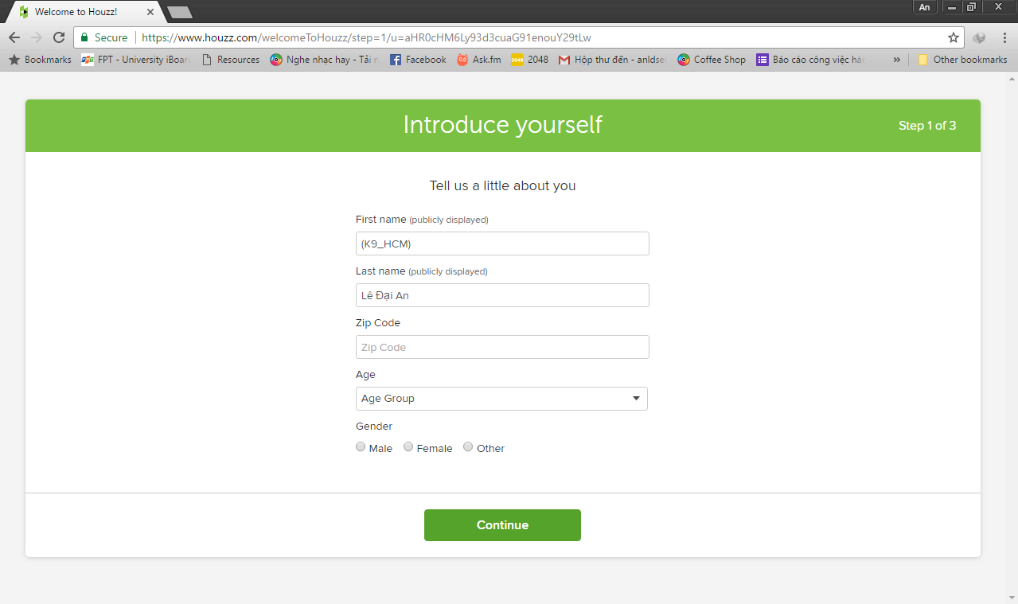

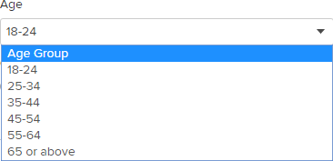

Step 2:

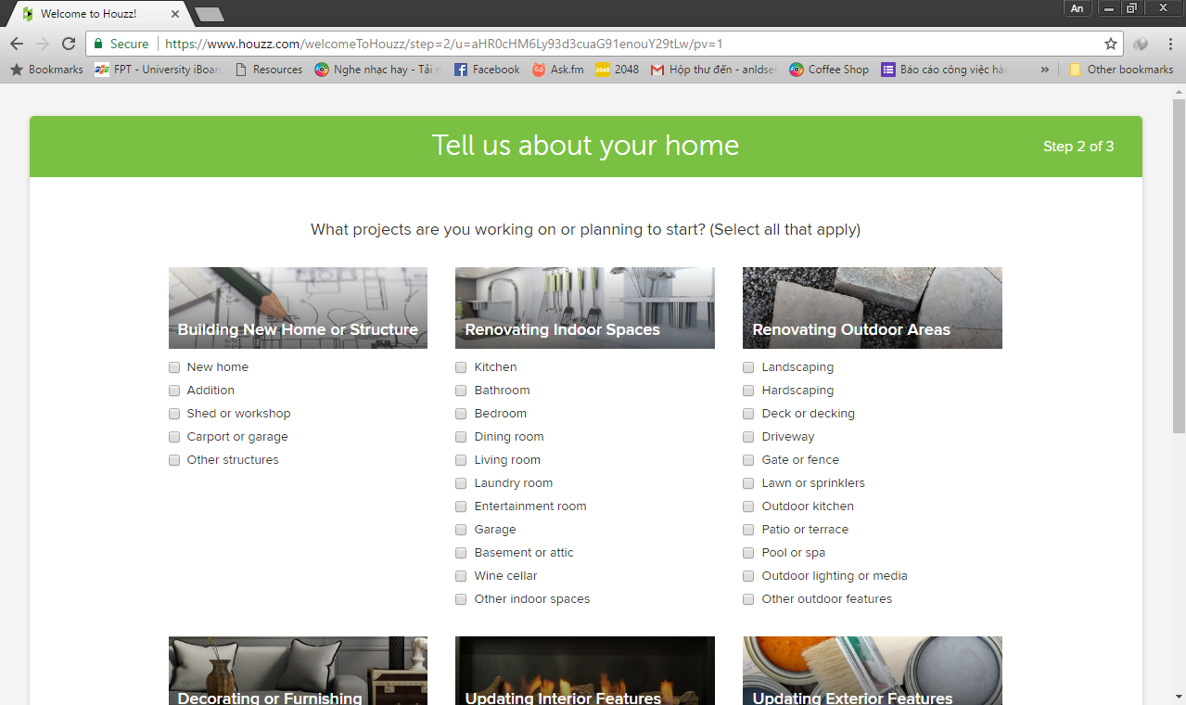

Step 3:

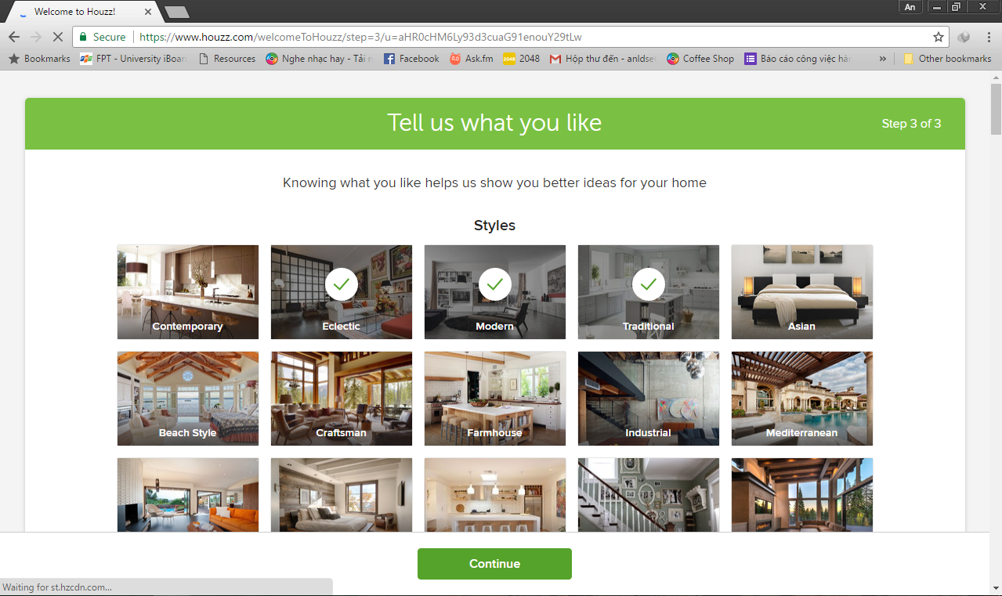

Upload photo lên houzz (tường nhà)

* Comment (text)
* Post to Followers, Post to Design Dilemma, Post to before & After

*Post to Design Dilemma, Post to before & After: have title for post*

* Select photo 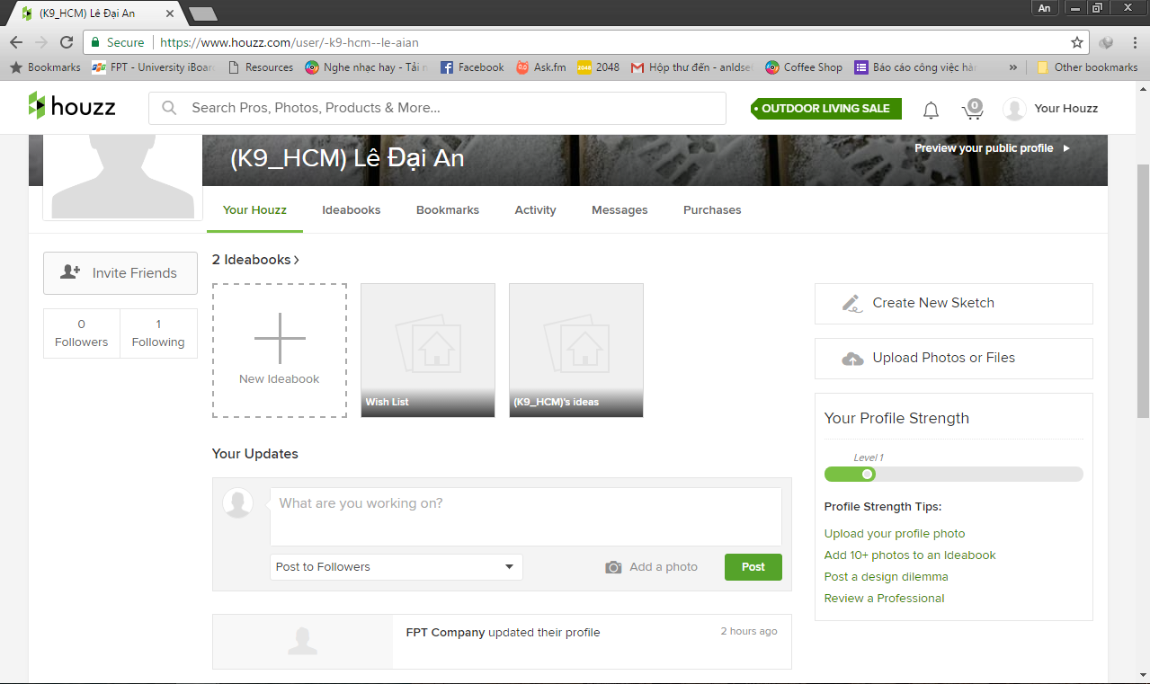

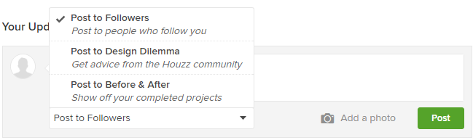

Upload photo vào 1 project cần:

**Select Project:**

* Create a new project
* Your existing projects

1. **Create a new project**

* New project name (text)
* Project address (text - optional)
* Category: spaces, products, drawings, before photos (select - optional)
* Project year: pre-2005 to 2017 (select - optional)
* Project cost (select range - optional)
* Styles: Asian; Beach style; Contemporary; Craftsman; Eclectric; Farmhouse; Industrial; Mediterranean; Midcentury; Modern; Rustic; Scandinavian; Shabby-Chic Style; Southwestern; Traditional; Transitional; Tropical; Victorian. (select - optional)
* Link to Website (text - optional)
* Keywords (separated by comma) (text - optional)
* Get noticed on other profiles by crediting other pros on this project (text - optional)
* Select photo

**Upload >>> đưa về trang edit photo information, nhập điều chỉnh 1 số thông tin**:

* Title (text - optional)
* Category (select - optional)
* Style (select - optional)
* Country (select - optional)
* City (text - optional)
* Zip/Postal Code (text - optional)

1. **Your existing projects**

* Category: spaces, products, drawings, before photos (select - optional)
* Styles: Asian; Beach style; Contemporary; Craftsman; Eclectric; Farmhouse; Industrial; Mediterranean; Midcentury; Modern; Rustic; Scandinavian; Shabby-Chic Style; Southwestern; Traditional; Transitional; Tropical; Victorian. (select - optional)
* Country (select - optional)
* Metro (select - optional)
* Link to website (text - optional)
* Get noticed on other profiles by crediting other pros on this project (text - optional)
* Select photo

**Upload >>> đưa về trang edit photo information như trên.**

Tạo idea book (home owner)

* Ideabook name (text)
* Description (text – optional)
* Privacy: public; private (select)
* Get feedback from family, friends, and pros: enter name and emails >> add 1 email to share, setting email can edit, view
* Sau đó add hình vào idea book

Nhập Shipping Addresses (home owner)

* Fullname (text)
* Address line 1 (text)
* Address line 2 (text)
* City (text)
* State/country/province (select)
* Postal code (text)
* Country (select)
* Phone number (text)
* *Extension*

*Tất cả đều bắt buộc, chỉ có extension là optional*

Nhập Billing info (home owner)

Payment Method:

* Name on card (text)
* Card number (text)
* Expiration date (select)
* Security code (text)

Billing address:

* Fullname (text)
* Address line 1 (text)
* Address line 2 (text)
* City (text)
* State/country/province (select)
* Postal code (text)
* Country (select)
* Phone number (text)
* *Extension*

*Tất cả đều bắt buộc, chỉ có extension là optional*